Earth Day 2021 email to teachers:
Hello!
Thursday, April 22nd is Earth Day. To celebrate, Cockeysville Middle School’s Green Club is sponsoring environmental activities that can be done through your advisory (or any class that ties into the curriculum) the next two weeks. Here’s what you can do:
- There are activities that can be done virtually, in person, or at home at a later time. All activities are posted in the Schoology group, “Morning Announcements” Resources April 2021 (see picture below). Pick and choose which would work best for you and your students. You may even have an “expert” Green Club member in your advisory who could lead an activity or do a presentation!

- Have students take a picture of what they are doing at home or at school and post it one of three ways: email it to me (adeborde@bcps.org), upload it to our Schoology site in the Earth Day folder called “Upload Earth Day pictures Here”, or post it on social media with hashtag, #BCPSGreen60 to the following BCPS accounts: @CockeysvilleMS; @BCPSOutdoorSci; @visualartsbcps; @bcpssci; @bcscsocial

Please let me know if you have any questions about Earth Day or any of the activities. You will also be seeing tips and facts about Earth Day in our upcoming announcements.
Thank you!
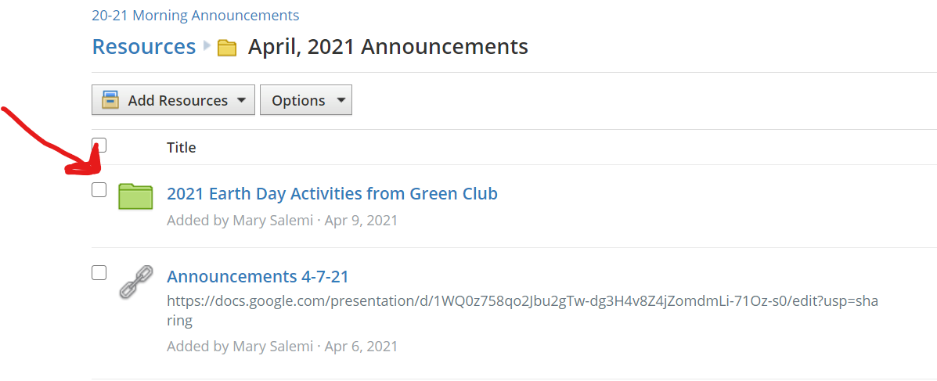
Autumn DeBorde

BCPS Green 60 Project:
The Baltimore County Student Councils Environmental Committee has developed a virtual environmental challenge students and schools can participate in titled Green 60 Our Planet, Our Home. The goals of this student-led challenge are threefold: 1. Raise awareness of current environmental issues 2. Reinforce the importance of climate education in younger students 3. Help decrease schools’ carbon footprints. Schools will receive points based on which activities their participants choose to complete. Some examples include, but are not limited to, submitting a video of participants cleaning up litter in their community or a photo submission of participants engaging in any of the ten possible sustainable practices listed by BCPS Dept of Facilities Management, developing a flyer or plan on how to keep our local environment clean and sustainable, or constructing any form of art based on the Green 60 theme. The ten possible sustainable practices are detailed in the attached Hybrid Earth Day Celebration flyer developed by Kelley Holocker with BCPS Office of Facilities Support Services.

